# Flotsam Cache Settings

OpenSimulator has an asset cache that stores the assets retrieved from an asset service. This reduces the load on a asset service and improves OpenSimulator responsiveness.

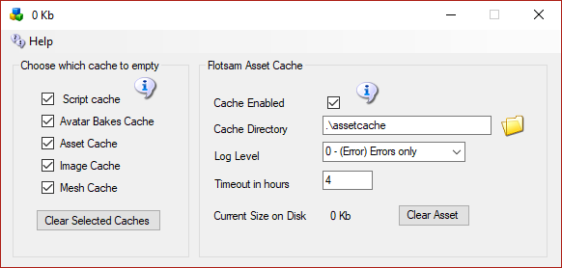

## Flotsam asset cache

The Flotsam asset cache, stores assets on disk and in memory.

At the moment, the amount of memory or filesystem storage used by the cache can only be limited via manual actions (wiping all or part of cached assets from the filesystem), by console commands (e.g. "fcache clear") or by timeout settings (e.g. FileCacheTimeout = 1 to automatically remove cache files not accessed for 1 hours).

## General principles

When OpenSimulator requires an asset (e.g., in response to a viewer request for a notecard), then it first asks the cache for this data. If the data is not found in the cache, then it asks the grid asset service (or a foreign asset service in the case of Hypergrid). If the asset is there, then it is both stored in the cache and returned to the user.

If an asset is uploaded to OpenSimulator (e.g., by the viewer uploading an animation), then the asset is at once both kept in cache (if there is room and the asset is not temporary) and sent to the asset service (if the asset is not temporary).

Therefore, at any point you can wipe any temporary data stored by the asset cache (e.g., on the filesystem), since the next request for that asset will simply query the asset service as the asset will not be found in cache.